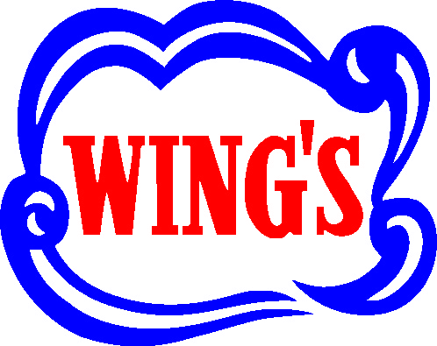
Eggrolls
Makes 17 eggrolls
INGREDIENTS:  - ¼ tsp sugar  - ½ tsp salt  - 1-1/2 tsp garlic salt  - 1-1/2 tsp Wing’s Soy Sauce  - 1-1/2 cup bean sprouts  - 1 cup celery, shredded  - ½ cup water  - ½ tsp cornstarch  - ½ medium onion, finely diced  - ½ cup water chestnuts, diced  - ½ cup bamboo shoots, shredded (optional)  - 2 tbsp vegetable oil  - 1 cup cabbage, shredded  - ½ lb ground chicken or turkey | PREPARATION:  1. In a large skillet, over medium heat, sauté onion in 2 tbsp of vegetable oil until softened. Add ground chicken or turkey and cook until it loses its pink colour.  2. Add sugar, salt, garlic salt, soy sauce, bean sprouts, celery, and cabbage. Sauté until all vegetables are softened.  3. Add water chestnuts and bamboo shoots. Heat through, approximately 5 minutes. Drain excess liquid and place aside in a large bowl.  4. In a small bowl, combine water and cornstarch. Place filling, 1-1/2 tbsp in the center of Wing’s Eggroll Wrapper. Follow above assembly directions. Deep fry until golden.  5. Drain on paper towel and serve hot with Wing’s Plum Sauce.
