# Home Page

* Rolling Banner: Link “Let’s Explore” does not work. Need it to link to product page <<http://wingsfoods.flywheelsites.com/product/fortune-cookies-2-5-kg-400-cookies/>>

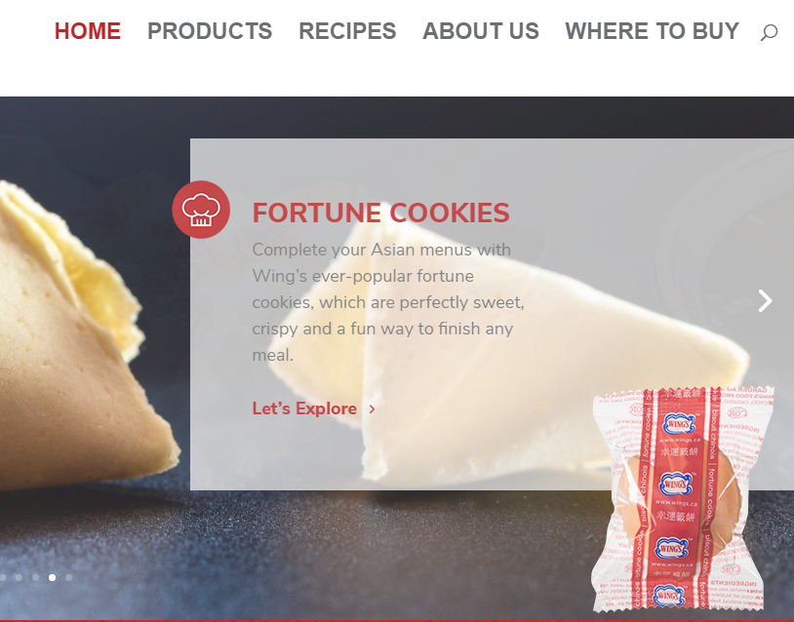 *This is for all products with the links “Let’s Explore”

* Product Category: Add the “Sauce” to the Category on the home page. Also change thumbnail image to circular instead of square.

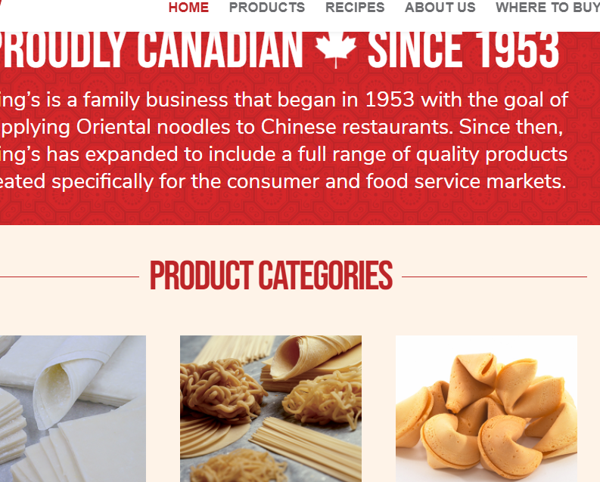

- *Sauce category photo – layout *white background with three individual sauces all in one picture. We have provided the individual sauce pack images.

* Replace photo with the provided High Resolution Image: 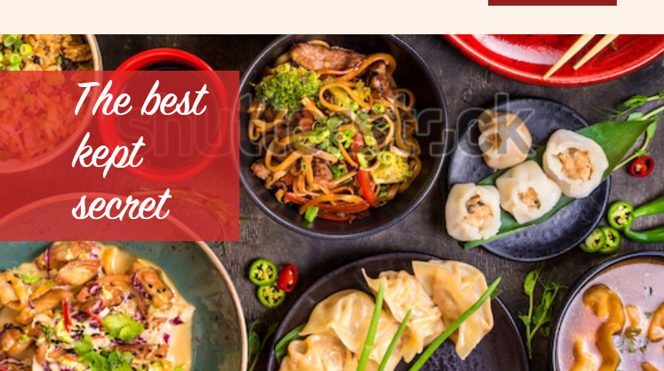 refer to file -- Home Page - the best kept secret
* Replace Recipe thumbnail photos with provided high resolution image:

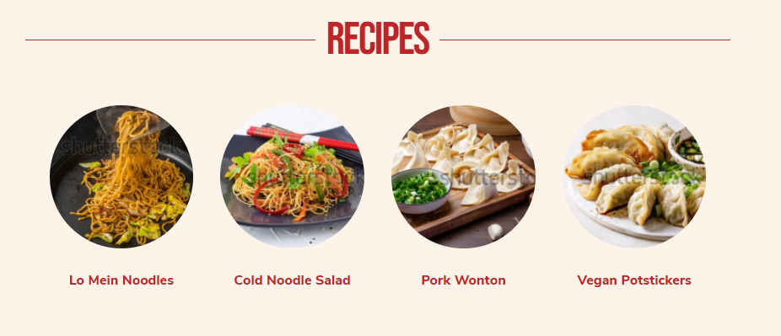

# Product Page

* Changing back to the original “product description” format. See image below

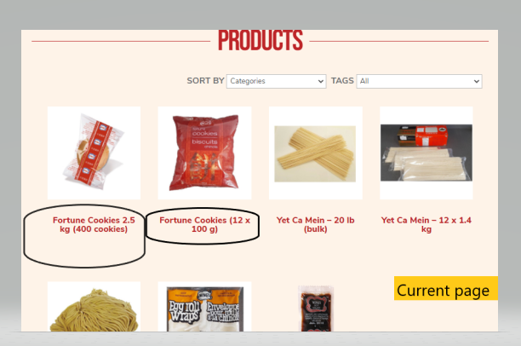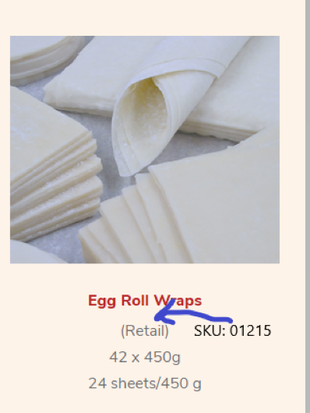

- Change description to old version

Like the Old version description format. Just wanted to add the product “**SKU # 01215”** under the title

Example:

* Item name+ dimension: Egg Roll Wrap 4.5”x 4.5”
* SKU# 01215
* Pack info: 42 x 450g
* #of sheets per unit: 24sheets/450g

Please refer to the brochure as reference: 

## Individual/Sub-Product Pages: E.g.-- <http://wingsfoods.flywheelsites.com/product/fortune-cookies-12-x-100-g/>

* 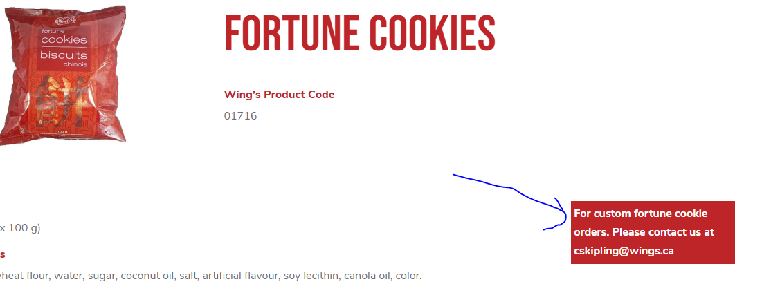 Remove the red box “For custom fortune cookie order. Please contact us at [cskipling@wings.ca](mailto:cskipling@wings.ca)” for all fortune cookie products

Make the Product tags visible under the Product name

* Format: Move “Wing’s Product Code” underneath image
* Under the Product name/title, add the **product tags**: Category (e.g. Fortune Cookies), Retail /Food Service, Available in Toronto /Available in Edmonton, Vegan
  + Refer to Product List & Tags file for reference
* **QUESTION**: Are we able to have more than one photo on the individual/sub Product page? Please provide us an example.

# Recipe Page

* Banner Image: Are we able to get the image a bit brighter/ vibrant? It appears a bit too dark.
* Eg. keep the thumbnail photos on the main “recipe page” circular instead of square
* Recipe sub pages: http://wingsfoods.flywheelsites.com/vegan-potstickers/

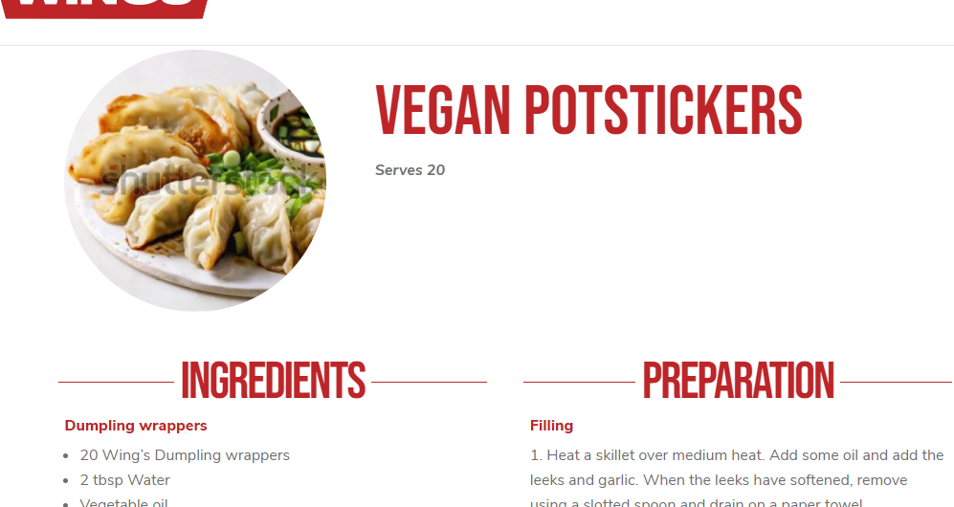Change the recipe into full size image.

# Where to Buy Page

- The Banner photos needs to be extended a bit more

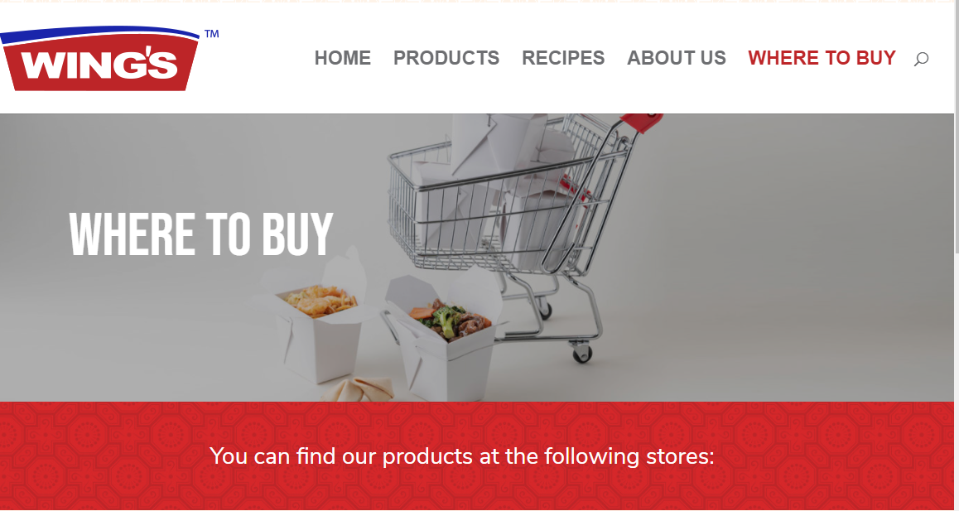 We want to be able to see the”full cart+ take-out box image” 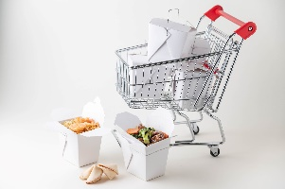

* Wanted a format similar format: Example layout: <https://ti-foods.com/our-valued-customer/> Are you able to provide the similar table style as the example above?

# Career page

* Please add the provided content 

# Term of Use Page:

Please add the content under “Term of us” 